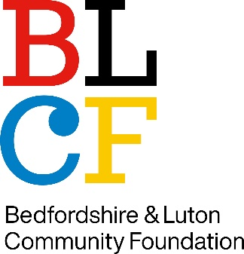
Recruitment Monitoring Form
Strictly confidential

The information you provide on this form is confidential and not shared but the information may be published in a summarised and anonymised form for trustees, in order to encourage transparency.

There is no requirement for you to provide any of the information on this form, and throughout we provide an opportunity for you not to answer each question. Notwithstanding this, it will help us make progress in our commitment to Diversity, Equity and Inclusion if you complete this form as fully as possible.

BLCF believes that:
- Diversity, Equity and Inclusion are all essential aspects of a charity’s approach to delivering its mission.
- Diversity of people brings diversity of perspective, skills and experience, which in turn can deliver richer creativity, better problem solving and greater impact for ourselves and our members.
- Leaders have a vital role in creating change by modelling positive behaviour and taking action.
- Everyone, no matter their background, should be able to access opportunities to fulfil their potential on a fair and equitable basis.
- Our service to our communities will be strengthened if our board has a broad range of direct experience and both lived and learned expertise.

What is your gender?  You can give an answer that is different to that on your birth certificate.  Gender “X” one box  Female  Male  Other  Prefer not to say | What is your age?  Age range “X” one box  16 to 30  31 to 40  41 to 50  51 to 60  61 plus  Prefer not to say
What is your ethnicity? (this is the ethnic group to which you perceive you belong)
Ethnicity | “X” one box or add
Asian/Asian British
Bangladeshi
Chinese
Indian
Pakistani
Other Asian ethnicity please add
Black/ African/ Caribbean/ Black British
African
Caribbean
USA
EU citizen
Any other Black ethnicity please describe
Mixed/multiple ethnic groups
Please describe your ethnic identity (e.g. Black/Asian)
White
British
Scottish
Welsh
English
Gypsy or Irish Traveller
Irish
European
Latin American
Turkey
Any other ethnicity please describe
Arab/Arab British
Arab origin
Any other ethnicity please describe
Prefer not to say
Prefer not to say

Do you consider yourself to have a disability or health condition that impacts on your participation in work or social activities?
Disability or health condition | “X” one box
Yes
No
Prefer not to say

What is your sexual orientation?
Sexual Orientation | “X” one box or add
Straight/Heterosexual
Gay or Lesbian
Bisexual
Other sexual orientation, please describe
Prefer not to say

What is your religion or belief?
Region or belief | “X” one box or add
No religion
Christian (including Church of England, Catholic, Protestant and all other Christian denominations)
Buddhist
Hindu
Jewish
Muslim
Sikh
Any other religion, please describe
Prefer not to say

Do you have caring responsibilities?
Caring responsibilities | Please “X” all that apply
None
Carer of child/children (under 18)
Carer of disabled child/children
Carer of disabled adult (18 and over)
Carer of older person
Prefer not to say

